__________
MASTER CHOA KOK SUI
__________________________________________________________________________________________________________________________________________________________________________________________________________________________________________________________________________________________________________________
BASIC PRANIC HEALING

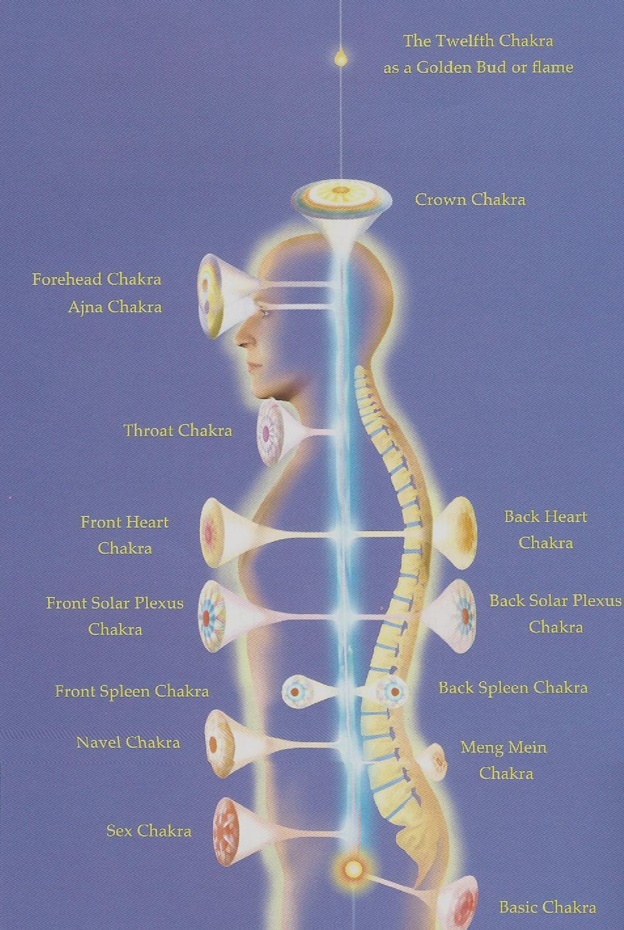
In two days learn and practice:

- Scanning to assess energetic causes of pain and disease.
- 11 Major Chakras, corresponding organs and symptoms
- Aura cleansing for lasting health and healing
- Simple steps to remove old, stagnant energies
- Powerful ways to revitalize the chakras and organs
- Cutting draining cords, to quickly let go of work-stress
- Energy first-aid for cuts, bruises, burns and sprains
- Energetic Hygiene to remain disease-free and feel good
- Twin Hearts Meditation
- Self-Pranic Healing
- Distant Pranic Healing to heal remotely
- Pranic Breathing to recharge yourself
- Foundational course towards certification

Saturday, March 28 , 2020 9:00am-5:00pm
Sunday, March 29, 2020 9:00am-5:00pm

Class Location:
The Harmony House
58 East Main St., Webster, NY

TRAINER: Dennis Caso is a Certified Pranic Healer and Pranic Healing instructor. His background as a Licensed Acupuncturist and over 19 years of Pranic Healing along with training in Taiji, QiGong and Medical QiGong under a Taoist Master, as well as training in Therapeutic Touch (under Deloris Kreiger) and training in Reiki provide a solid base in energy healing. Combined with his background in teaching at Elmira College provide a strong background for teaching Pranic Healing. Dennis has also published articles about Pranic Healing.

To register, contact Dennis Caso (607) 793-1360
e-mail: nypranichealing@aol.com
Mailing address: 1076 Elmira Rd., Newfield, NY 14867
Web site: whitelotuspranichealing.com

Workshop Fee: Early registration price $295 until March 21, 2020, (Credit card, Cash, or Check payable to White Lotus Pranic Healing).

Advanced classes in 2020

All courses are under the auspices of The Center for Pranic Healing

